Business Rules

# Discount on Product

productDiscount (%)

productPrice (Real Price)

Display on Index and Details Page:

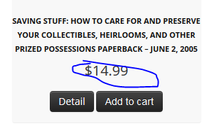 => Selling Price

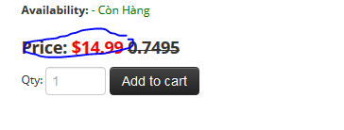 => Selling Price

**Selling Price = productPrice – (productPrice * productDiscount / 100);**

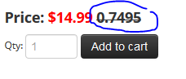=> productPrice

# Discount on Order

Based on Customer point

**Total Price of Order = 10$ ⬄ 1 point**

When user place an order , if user want to use their point to take an discount for their order

**10 point ⬄ 1$**

# Admin Page

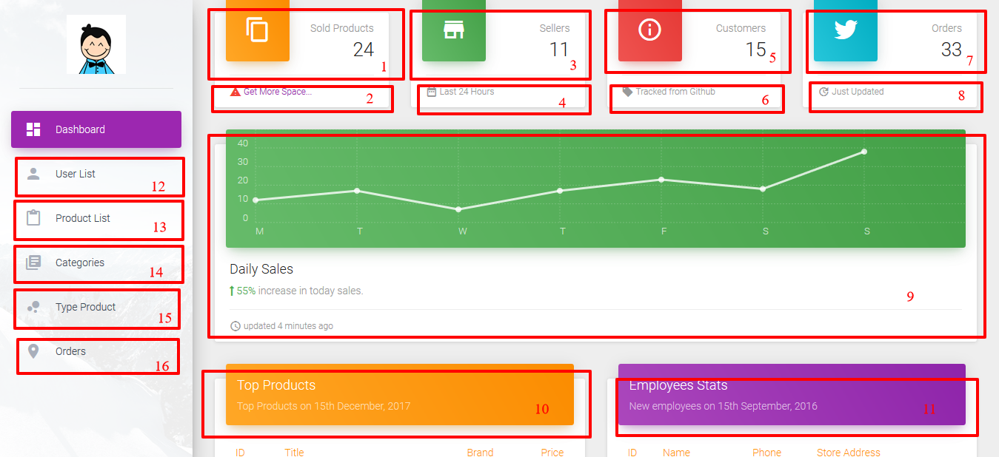

1. Sold product: Product that have been ordered
2. Print Report: Id, Name, Quantity, OrderMId, Date Ordered, Status
3. Sellers: Numbers of Sellers
4. Print Report: Id, Name, Store Name, Numbers of Orders, Numbers of Products
5. Customers: Numbers of Customers
6. Print Report: Id, Customer Name, Phone, Numbers of Orders, Numbers of Comments
7. Orders: Numbers of Orders been placed
8. Print Report: Id, UsersId (buyer), Total Price, ProductQuantity, Status
9. Sold Products every month <Concern>
10. Top products: Products have been sold with most quantities: Id, Name, Users Id (Seller or admin), price, quantity (maybe no need)
11. Sellers: List of Sellers: Id, Store name, Phone, Store Address
12. Separate for two list : Customer List and Seller List:
    1. Customer List: ID, Name, Date of Birth, Gender, Address, Point, Block button
    2. Seller List: Id, Name, Store Name, Store Address, Phone, Block button
13. Product List: Id, Product Name, Brand, Image, Quantity, View History button, Block button
    1. Click on Id can update Product Information
    2. Based on Owner will hightlight row with different color: Admin – Red, Other Seller – Green. And font color will be black
    3. Click on name can view more detail product <Concern>
14. Categories: Id, Name, Description, Icon, Block button
    1. Click on Id can update Category information
15. Product Type: Id, Name, Description, Icon, Block button
    1. Click on Id can update Product Type Information
    2. Click on Name can view Product list of type <Concern>
16. Orders: Id, Buyer, Date, Note, total Price, Status, block button
    1. Based on Status will hightlight row with different color: Done – Green, Processing – Orange, Delivery – blue, Cancel – Red. And font color will be black
    2. Click on Name can view Order Details <Concern>

# Seller Page

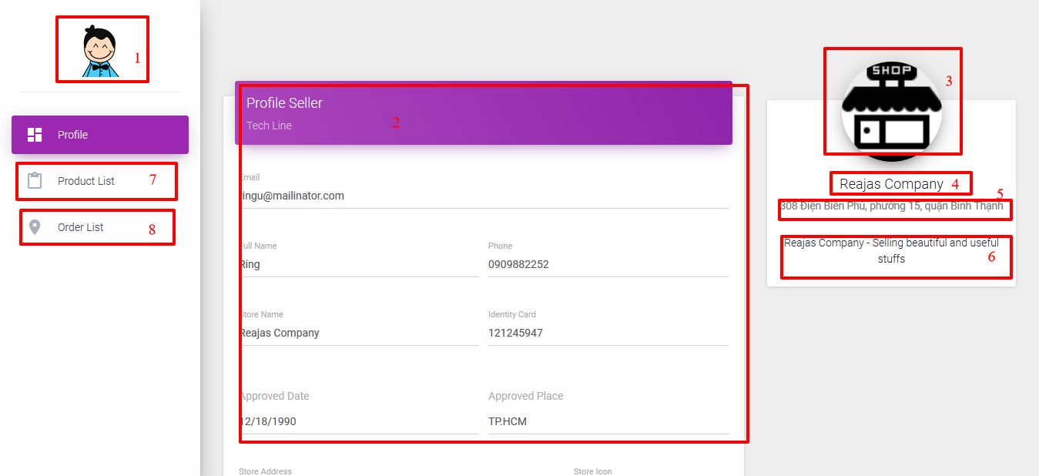

1. Same as Admin: back to home page (index of website)
2. Profile of seller
3. Icon of Seller
4. Store Name
5. Store Address
6. Store Summary
7. List Product of Seller – Same design with product list of admin but none with hightlight color
8. List Order – Same design with seller of admin

# Index Page

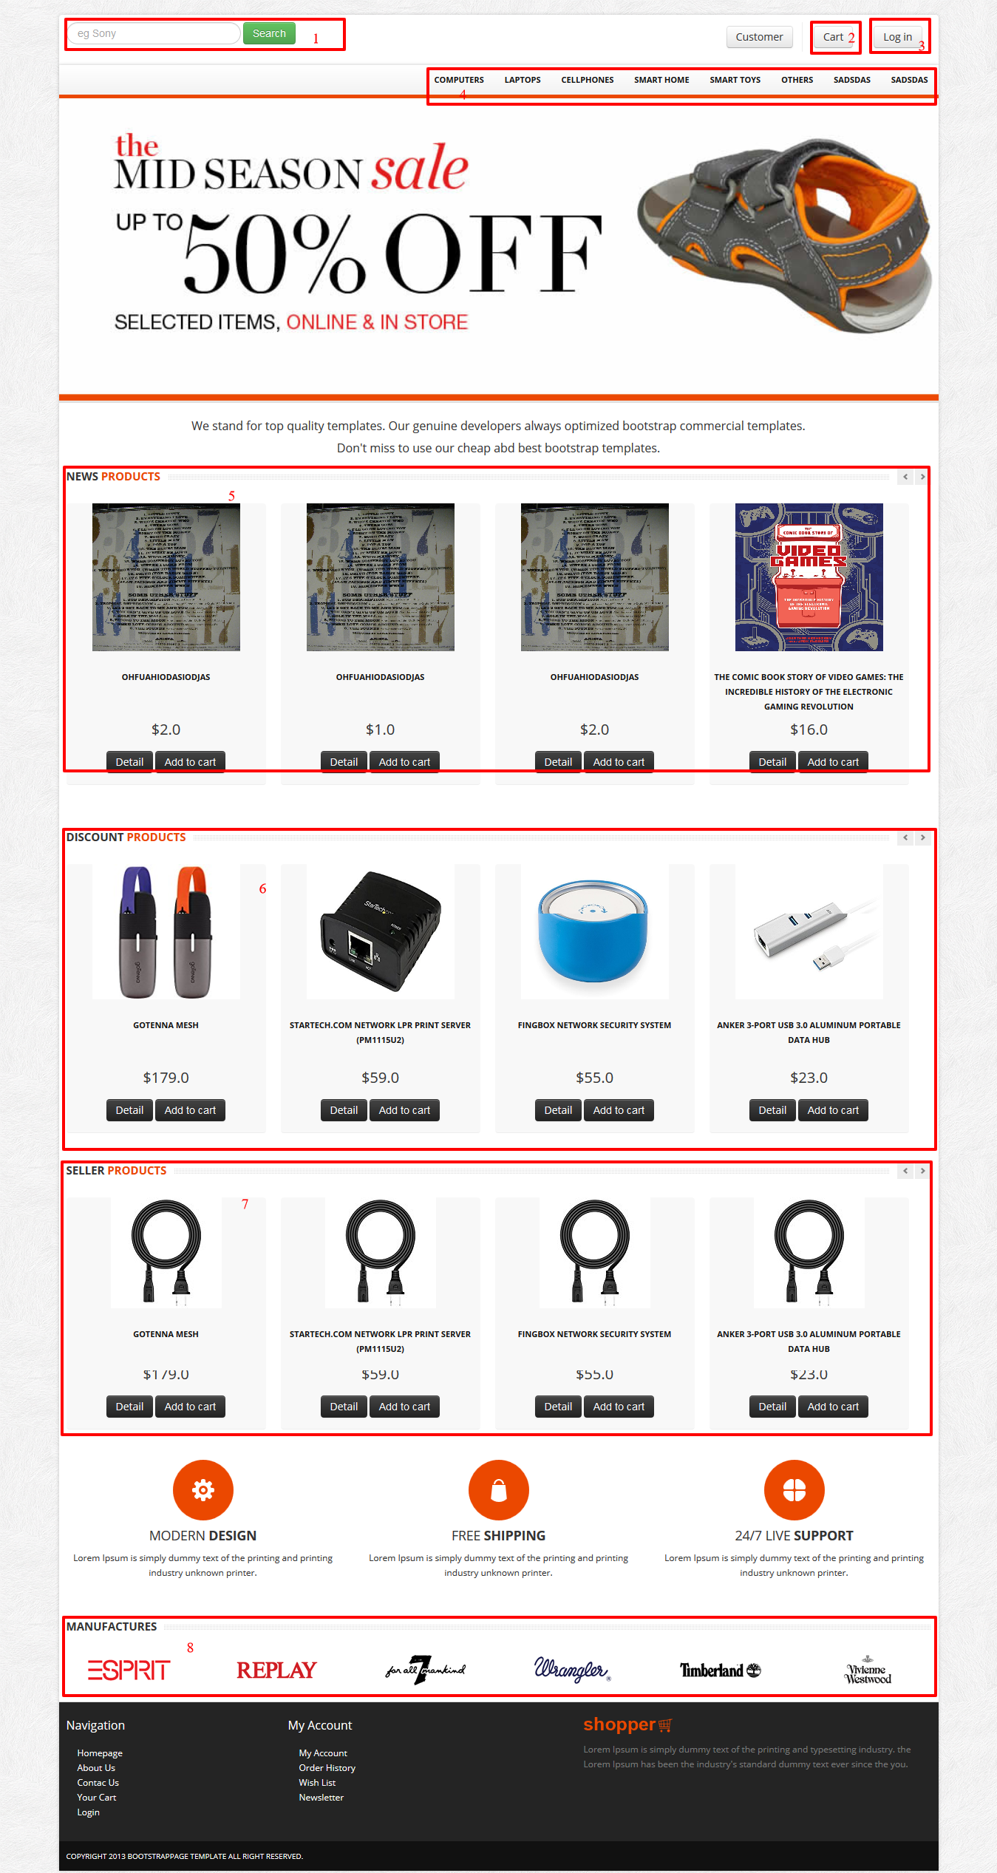

1. Search based on Product Name
2. Cart of Customer
3. Login
4. Categories
   1. Dropdown will show product type and can go on to typeDetail if clicked
   2. Clicked on will go to catdetail with catid
5. Products that have been posted recently
   1. Detail will go to detail page of product
   2. Add to cart will add to cart for user if logged in
6. Products that have discount will show price follow details page
7. Products of seller
8. Brands icon

# Detail Page

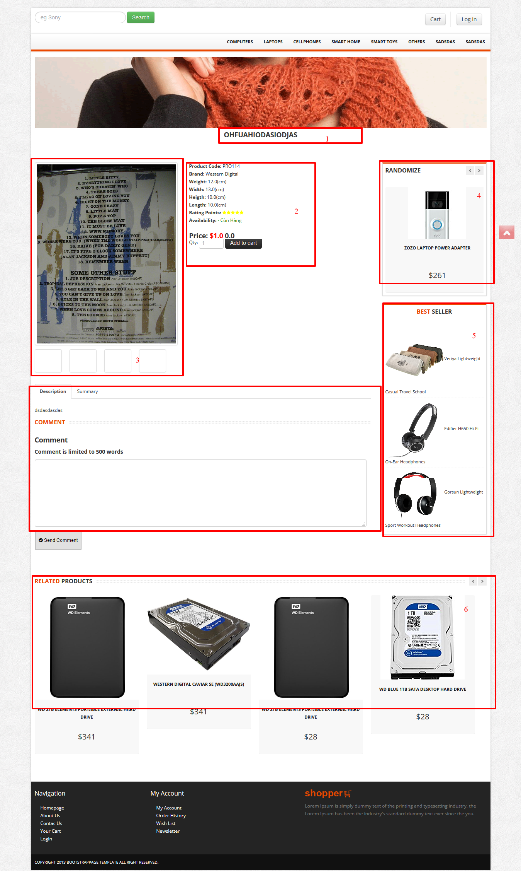

1. Product Name
2. Product Information with price show as discount on product rule
3. Images
4. Random product as same product type
5. Top products (based on order) among all products
6. Related products based on products type sort by dateposted

# Delivery Price

For 12km price will be 1km = 2$

More than 12km, 1km = 3$